U.S. Antimony Reports Progress on Gold and Silver Leach Plant and Strong Zeolite Sales
THOMPSON FALLS, MT / ACCESSWIRE / May 7, 2018 / United States Antimony Corporation ("USAC", NYSE American: UAMY) reported progress on the construction of the leach plant for the Los Juarez gold-silver-antimony deposit in Queretaro, Mexico. The excavation and lining of the tailings pond is the largest and most expensive project, and it is underway. The concrete floor of the leach plant is being poured and initially no building will be necessary over the floor. Much of the equipment is being assembled in Montana and also in Mexico. Testing and shake-down of the plant is anticipated in Q4 2018.
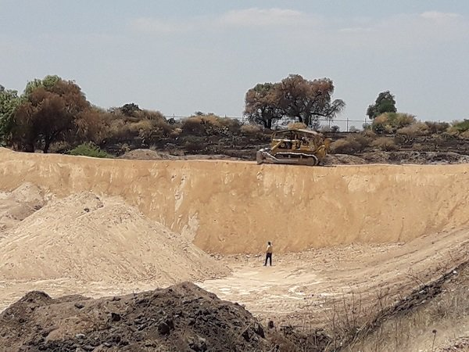
Tailings pond construction

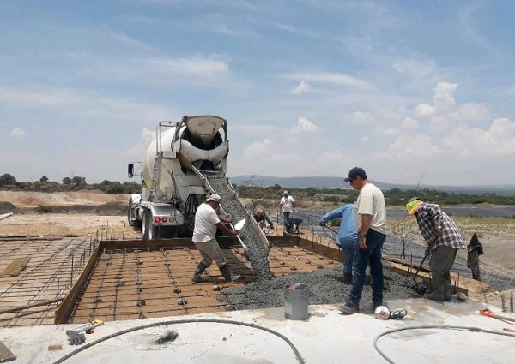
Pouring concrete for leach plant
BRZ zeolite sales for most applications were up again in April.
Estimated sales for the month of April 2018 were as follows:

Antimony pounds | 136,812
Zeolite short tons | 1,424

The average Rotterdam price antimony metal was $8,525.00 per metric ton or $3.866. USAC generally sells antimony contained for more than $4.00 per pound. Mexican production rivals our North American supply.
CEO John Lawrence said, "After years of waiting on cyanide permit, we are excited about the construction of the leach plant and imminent production of gold and silver. For years many shareholders considered the Los Juarez property as USAC's "crown jewel", and the belief was slowly abandoned due to the metallurgical work and the permit delays. We expect to announce our progress on several additional strategic and financial opportunities that do not involve dilution of any kind."
About U.S. Antimony
US Antimony is a growing, vertically-integrated natural resource company that has production and diversified operations in precious metals, zeolite and antimony.
Forward Looking Statements:
This Press Release contains forward-looking statements within the meaning of Section 27A of the Securities Act of 1933 and Section 21E of the Securities Exchange Act of 1934 that are based upon current expectations or beliefs, as well as a number of assumptions about future events, including matters related to the Company's operations, pending contracts and future revenues, ability to execute on its increased production and installation schedules for planned capital expenditures and the size of forecasted deposits. Although the Company believes that the expectations reflected in the forward-looking statements and the assumptions upon which they are based are reasonable, it can give no assurance that such expectations and assumptions will prove to have been correct. The reader is cautioned not to put undue reliance on these forward-looking statements, as these statements are subject to numerous factors and uncertainties. In addition, other factors that could cause actual results to differ materially are discussed in the Company's most recent filings, including Form 10-KSB with the Securities and Exchange Commission.
SOURCE: United States Antimony Corporation

